**NFT ASSIGNMENT-1**

**Objective:** Loan Approval Prediction using Machine Learning

**Problem Statement:**

Dream Housing Finance company deals in all kinds of home loans. They have presence across all urban, semi urban and rural areas. Customer first applies for home loan and after that company validates the customer eligibility for loan.

Company wants to automate the loan eligibility process (real time) based on customer detail provided while filling online application form. These details are Gender, Marital Status, Education, Number of Dependents, Income, Loan Amount, Credit History and others. To automate this process, they have provided a dataset to identify the customers segments that are eligible for loan amount so that they can specifically target these customers.

**Input Dataset**: <https://drive.google.com/file/d/1LIvIdqdHDFEGnfzIgEh4L6GFirzsE3US/view>

**Output Targeted :**The output is given in 0’s(not approved) or 1’s (approved).  
  
**Data Collection:**Data is collected from website:

<https://www.kaggle.com/datasets/altruistdelhite04/loan-prediction-problem-dataset>

| **Variable** | **Description** |
| --- | --- |
| Loan_ID | Unique Loan ID |
| Gender | Male/ Female |
| Married | Applicant married (Y/N) |
| Dependents | Number of dependents |
| Education | Applicant Education (Graduate/ Under Graduate) |
| Self_Employed | Self employed (Y/N) |
| ApplicantIncome | Applicant income |
| CoapplicantIncome | Coapplicant income |
| LoanAmount | Loan amount in thousands |
| Loan_Amount_Term | Term of loan in months |
| Credit_History | credit history meets guidelines |
| Property_Area | Urban/ Semi Urban/ Rural |
| Loan_Status | Loan approved (Y/N) |

**2. Data Preprocessing:**

**Handling Missing Values**:

Filled missing values in "LoanAmount," "Loan_Amount_Term," and "Credit_History" with their respective means.

df.isnull().sum()

Loan_ID 0

Gender 13

Married 3

Dependents 15

Education 0

Self_Employed 32

ApplicantIncome 0

CoapplicantIncome 0

LoanAmount 22

Loan_Amount_Term 14

Credit_History 50

Property_Area 0

Loan_Status 0

dtype: int64

df['LoanAmount']=df['LoanAmount'].fillna(df['LoanAmount'].mean())

df['Loan_Amount_Term']=df['Loan_Amount_Term'].fillna(df['Loan_Amount_Term'].mean())

df['Credit_History']=df['Credit_History'].fillna(df['Credit_History'].mean())

df.isnull().sum()

Loan_ID 0

Gender 13

Married 3

Dependents 15

Education 0

Self_Employed 32

ApplicantIncome 0

CoapplicantIncome 0

LoanAmount 0

Loan_Amount_Term 0

Credit_History 0

Property_Area 0

Loan_Status 0

dtype: int64

Imputed missing values in "Gender," "Married," "Dependents," and "Self_Employed" with the mode.

df['Gender']=df["Gender"].fillna(df['Gender'].mode()[0])

df['Married']=df["Married"].fillna(df['Married'].mode()[0])

df['Dependents']=df["Dependents"].fillna(df['Dependents'].mode()[0])

df['Self_Employed']=df["Self_Employed"].fillna(df['Self_Employed'].mode()[0])

df.isnull().sum()

Loan_ID 0

Gender 0

Married 0

Dependents 0

Education 0

Self_Employed 0

ApplicantIncome 0

CoapplicantIncome 0

LoanAmount 0

Loan_Amount_Term 0

Credit_History 0

Property_Area 0

Loan_Status 0

dtype: int64

**Data Transformation:**

Applied log transformation to "ApplicantIncome," "CoapplicantIncome," "LoanAmount," "Loan_Amount_Term," and created corresponding log-transformed columns.

df['ApplicantIncome'] = np.log(df['ApplicantIncome'])

df['CoapplicantIncome'] = np.log(df['CoapplicantIncome'] + 1)  # Adding 1 to avoid log(0)

df['LoanAmount'] = np.log(df['LoanAmount'])

df['Loan_Amount_Term'] = np.log(df['Loan_Amount_Term'] + 1)  # Adding 1 to avoid log(0)

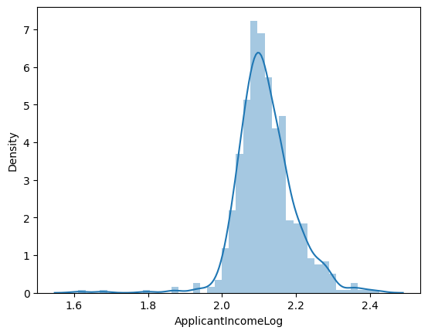 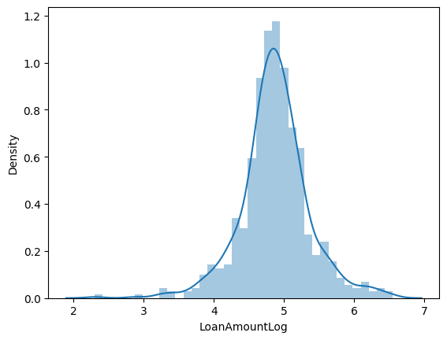

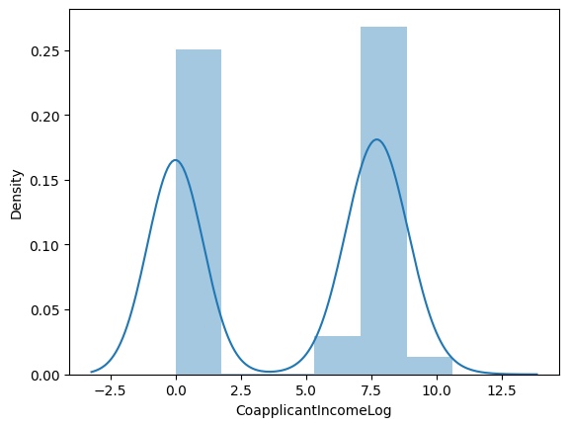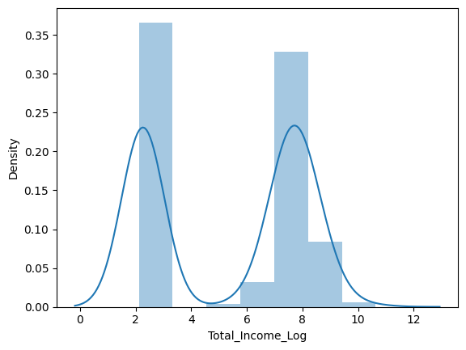

**3. Data Labeling:**

Encoded categorical variables like Gender, Married, Dependents, Education, Self_Employed, Property_Area, Loan_Status using LabelEncoder.

encoder = LabelEncoder()

categorical_columns = ['Gender', 'Married', 'Dependents', 'Education', 'Self_Employed', 'Property_Area', 'Loan_Status']

for col in categorical_columns:

    df[col] = encoder.fit_transform(df[col])

**4. Data Split:**

Utilized StratifiedShuffleSplit to split the dataset into training and testing sets, maintaining class distribution.

# Data Split

X = df.drop(columns=['Loan_Status', 'Loan_ID'], axis=1)

y = df['Loan_Status']

X_train, X_test, y_train, y_test = train_test_split(X, y, test_size=0.2, random_state=42)

# Standardize the features

scaler = StandardScaler()

X_train = scaler.fit_transform(X_train)

X_test = scaler.transform(X_test)

**5. Artificial Neural Model:**

We constructed multi-layer perceptron (MLP) with one hidden layer and error back propagation included in it:

Input Layer: Number of neurons equal to the number of input features.

Hidden Layer 1: 128 neurons with sigmoid activation function.

Output Layer: 1 neuron with a sigmoid activation function.

**3. Data set being used for the problem statement**<https://drive.google.com/file/d/1LIvIdqdHDFEGnfzIgEh4L6GFirzsE3US/view>

**DONE BY:**

**BT21CSE100-Katnapalli Rishitha**

**BT21CSE106-Anandapu Srihitha**